Control Your Temper (Anger)
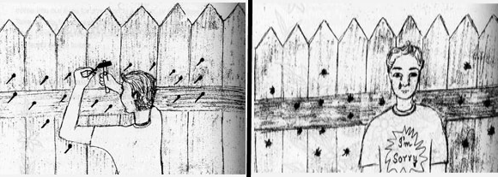
There once was a little boy who had a very bad temper. His father decided to hand him a bag of nails and said that every time the boy lost his temper, he had to hammer a nail into the fence.
On the first day, the boy hammered 37 nails into that fence.
The boy gradually began to control his temper over the next few weeks, and the number of nails he was hammering into the fence slowly decreased. He discovered it was easier to control his temper than to hammer those nails into the fence.
Finally, the day came when the boy didn’t lose his temper at all. He told his father the news and the father suggested that the boy should now pull out a nail every day he kept his temper under control.
The days passed and the young boy was finally able to tell his father that all the nails were gone. The father took his son by the hand and led him to the fence.
“you have done well, my son, but look at the holes in the fence. The fence will never be the same. When you say things in anger, they leave a scar just like this one. You can put a knife in a man and draw it out. It won’t matter how many times you say I’m sorry, the wound is still there.”
Moral of the story: Control your anger, and don’t say things to people in the heat of the moment, that you may later regret. Some things in life, you are unable to take back.

文章來源：
https://wealthygorilla.com/10-most-inspirational-short-stories/
QR code

